Challenge of Jenkins-01
Use the below code and implement our CICD stages.
- Source Code: https://github.com/betawins/hiring-app.git
  - Repository contains the application code for the hiring app.
- Create one Declarative pipeline job
Added the details below from the repo above provided:
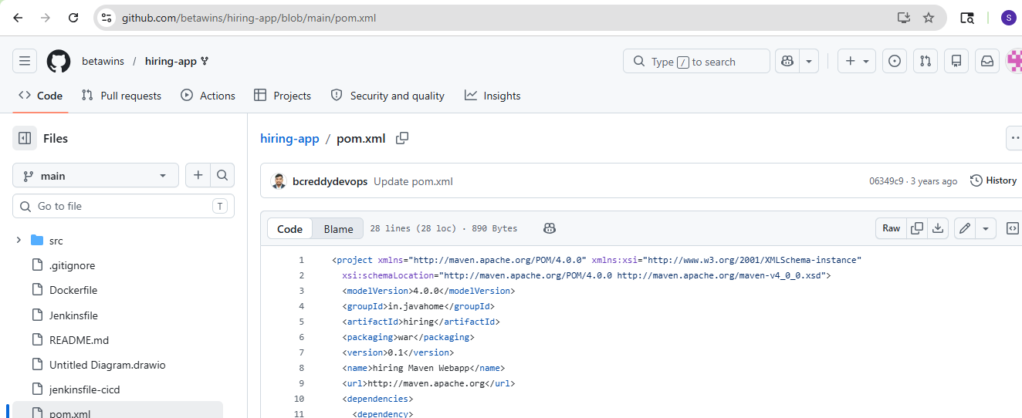
Used the below pipeline script:
pipeline {

- agent any

- tools {
- maven 'Maven-home'

- }

- environment {

- // SonarQube
- SCANNER_HOME = tool 'Sonar-scanner'

- // Nexus
- NEXUS_VERSION = "nexus3"
- NEXUS_PROTOCOL = "http"
- NEXUS_URL = "13.53.75.17:8081"
- NEXUS_REPOSITORY = "hiring-app"
- NEXUS_CREDENTIAL_ID = "Nexus-task-6000"

- // Artifact Details
- GROUP_ID = "in.javahome"
- ARTIFACT_ID = "hiring"
- VERSION = "1.0.${BUILD_NUMBER}-SNAPSHOT"

- // Tomcat
- TOMCAT_URL = "http://16.170.219.9:8080/"
- TOMCAT_CREDENTIAL_ID = "Tomcat-server"

- // Slack
- SLACK_CHANNEL = "all-jenkins-sonar"
- }

- stages {

- stage('Clean Workspace') {
- steps {
- cleanWs()
- }
- }

- stage('Clone Source Code') {
- steps {

- git branch: 'main',
- url: 'https://github.com/betawins/hiring-app.git'
- }
- }

- stage('Build Application') {
- steps {

- sh "${tool 'Maven-home'}/bin/mvn clean install"
- }
- }

- stage('Run Unit Tests') {
- steps {

- sh 'mvn test'
- }
- }

- stage('SonarQube Code Analysis') {

- steps {

- withSonarQubeEnv('Sonarqube') {

- sh """
- ${SCANNER_HOME}/bin/sonar-scanner \
- -Dsonar.projectKey=hiring-app \
- -Dsonar.projectName=hiring-app \
- -Dsonar.sources=.
- """
- }
- }
- }

- stage('Package Application') {

- steps {

- sh 'mvn clean package'
- }
- }

- stage('Archive Artifact') {

- steps {

- archiveArtifacts artifacts: 'target/hiring.war'
- }
- }

- stage('Upload WAR to Nexus') {

- steps {

- nexusArtifactUploader(

- nexusVersion: NEXUS_VERSION,
- protocol: NEXUS_PROTOCOL,
- nexusUrl: NEXUS_URL,
- repository: NEXUS_REPOSITORY,
- credentialsId: NEXUS_CREDENTIAL_ID,
- groupId: GROUP_ID,
- version: VERSION,

- artifacts: [
- [
- artifactId: ARTIFACT_ID,
- classifier: '',
- file: 'target/hiring.war',
- type: 'war'
- ]
- ]
- )
- }
- }

- stage('Deploy to Tomcat') {

- steps {

- deploy adapters: [
- tomcat9(
- credentialsId: TOMCAT_CREDENTIAL_ID,
- path: '',
- url: "${TOMCAT_URL}"
- )
- ],

- contextPath: 'hiring-app',
- war: 'target/hiring.war'
- }
- }
- }

- post {

- success {

- slackSend(
- channel: "${SLACK_CHANNEL}",
- color: 'good',
- message: """
- SUCCESS:
- Job Name: ${env.JOB_NAME}
- Build Number: ${env.BUILD_NUMBER}
- Build URL: ${env.BUILD_URL}
- """
- )
- }

- failure {

- slackSend(
- channel: "${SLACK_CHANNEL}",
- color: 'danger',
- message: """
- FAILED:
- Job Name: ${env.JOB_NAME}
- Build Number: ${env.BUILD_NUMBER}
- Build URL: ${env.BUILD_URL}
- """
- )
- }
- }
- }
SonarQube result also showed:
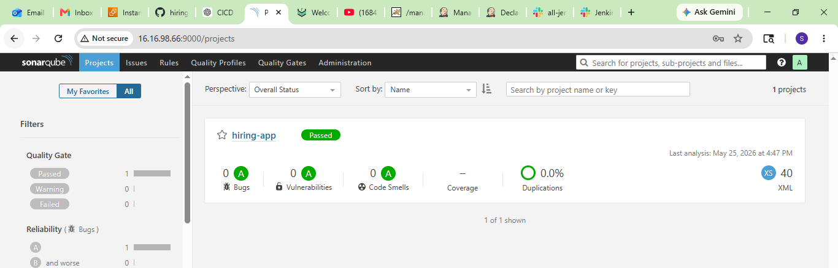
Job successfully executed:
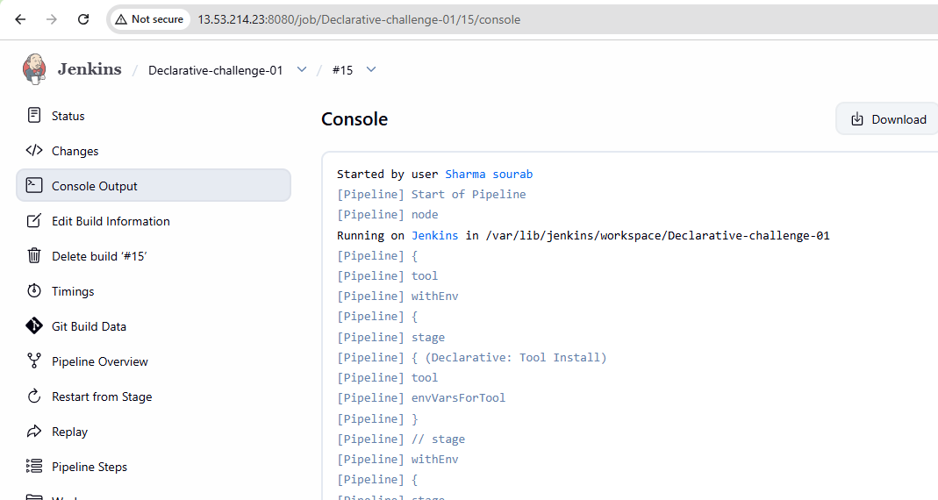
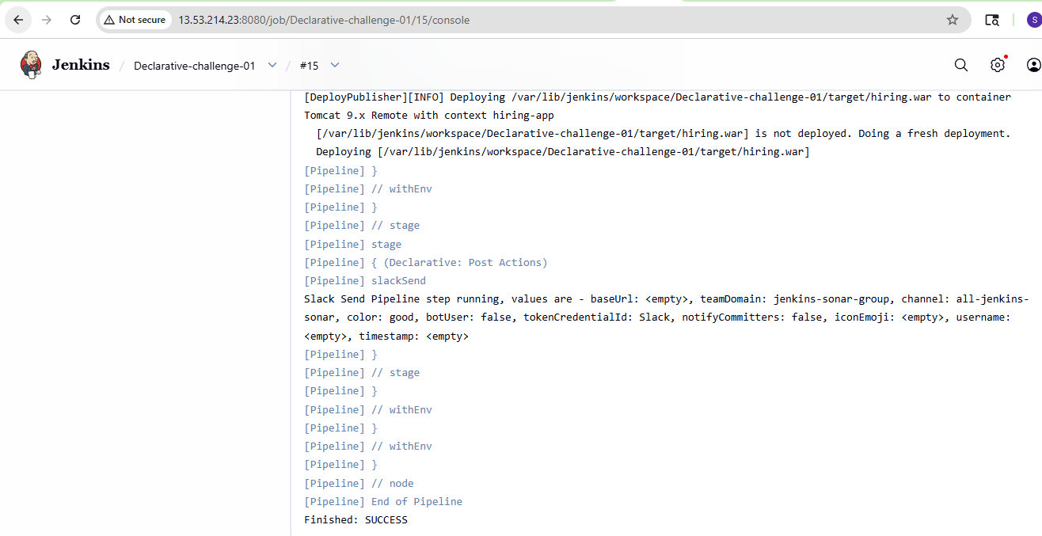
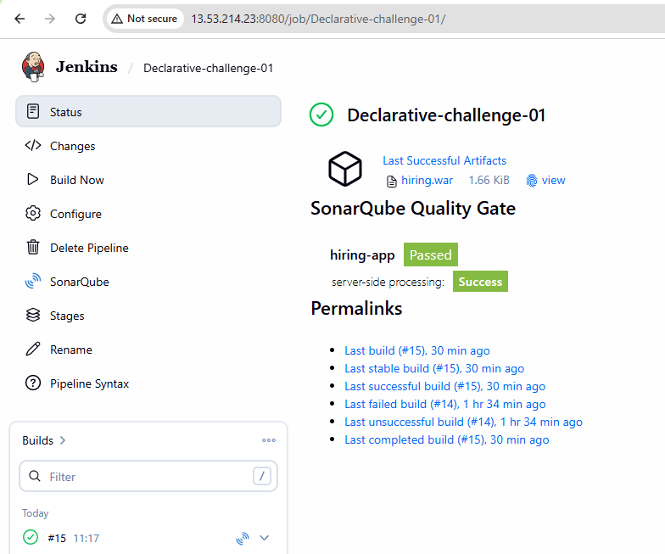
Received the slack notification also:
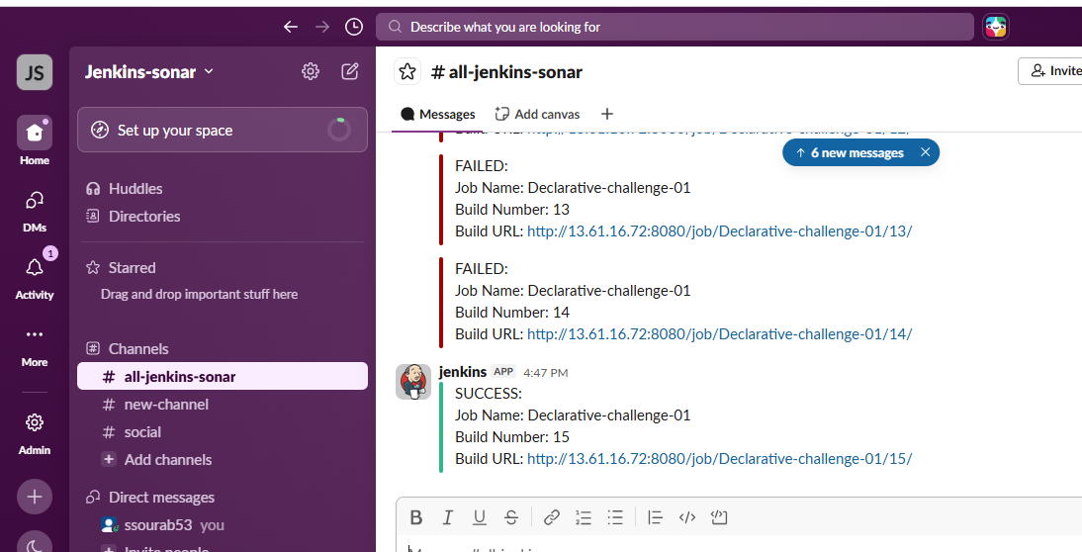
Checked with the browser also:
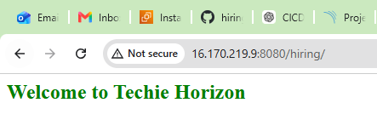
- Create one Scripted pipeline job:
Used the same above scripts and asked ChatGPT to give a scripted pipeline:
node {

- def SCANNER_HOME
- def NEXUS_VERSION = "nexus3"
- def NEXUS_PROTOCOL = "http"
- def NEXUS_URL = "13.53.75.17:8081"
- def NEXUS_REPOSITORY = "hiring-app"
- def NEXUS_CREDENTIAL_ID = "Nexus-task-6000"

- def GROUP_ID = "in.javahome"
- def ARTIFACT_ID = "hiring"
- def VERSION = "1.0.${BUILD_NUMBER}-SNAPSHOT"

- def TOMCAT_URL = "http://16.170.219.9:8080/"
- def TOMCAT_CREDENTIAL_ID = "Tomcat-server"

- def SLACK_CHANNEL = "all-jenkins-sonar"

- try {

- stage('Initialize Tools') {

- env.PATH = "${tool 'Maven-home'}/bin:${env.PATH}"
- SCANNER_HOME = tool 'Sonar-scanner'

- sh 'mvn -version'
- }

- stage('Clean Workspace') {

- cleanWs()
- }

- stage('Clone Source Code') {

- git(
- branch: 'main',
- url: 'https://github.com/betawins/hiring-app.git'
- )
- }

- stage('Build Application') {

- sh 'mvn clean install'
- }

- stage('Run Unit Tests') {

- sh 'mvn test'
- }

- stage('SonarQube Code Analysis') {

- withSonarQubeEnv('Sonarqube') {

- sh """
- ${SCANNER_HOME}/bin/sonar-scanner \
- -Dsonar.projectKey=hiring-app \
- -Dsonar.projectName=hiring-app \
- -Dsonar.sources=.
- """
- }
- }

- stage('Package Application') {

- sh 'mvn clean package'
- }

- stage('Archive Artifact') {

- archiveArtifacts(
- artifacts: 'target/hiring.war',
- fingerprint: true
- )
- }

- stage('Upload WAR to Nexus') {

- nexusArtifactUploader(

- nexusVersion: NEXUS_VERSION,
- protocol: NEXUS_PROTOCOL,

- nexusUrl: NEXUS_URL,

- repository: NEXUS_REPOSITORY,

- credentialsId: NEXUS_CREDENTIAL_ID,

- groupId: GROUP_ID,

- version: VERSION,

- artifacts: [[

- artifactId: ARTIFACT_ID,

- classifier: '',

- file: 'target/hiring.war',

- type: 'war'
- ]]
- )
- }

- stage('Deploy to Tomcat') {

- deploy(

- adapters: [

- tomcat9(
- credentialsId: TOMCAT_CREDENTIAL_ID,
- path: '',
- url: TOMCAT_URL
- )
- ],

- contextPath: 'hiring-app',

- war: 'target/hiring.war'
- )
- }

- currentBuild.result = 'SUCCESS'

- slackSend(
- channel: SLACK_CHANNEL,

- color: 'good',

- message: """
- SUCCESS

- Job Name: ${env.JOB_NAME}

- Build Number: ${env.BUILD_NUMBER}

- Build URL: ${env.BUILD_URL}
- """
- )

- } catch(Exception e) {

- currentBuild.result = 'FAILURE'

- slackSend(

- channel: SLACK_CHANNEL,

- color: 'danger',

- message: """
- FAILED

- Job Name: ${env.JOB_NAME}

- Build Number: ${env.BUILD_NUMBER}

- Build URL: ${env.BUILD_URL}

- Reason:
- ${e}
- """
- )

- throw e

- } finally {

- cleanWs()
- }
- }
Used the same below and job got executed successfully.
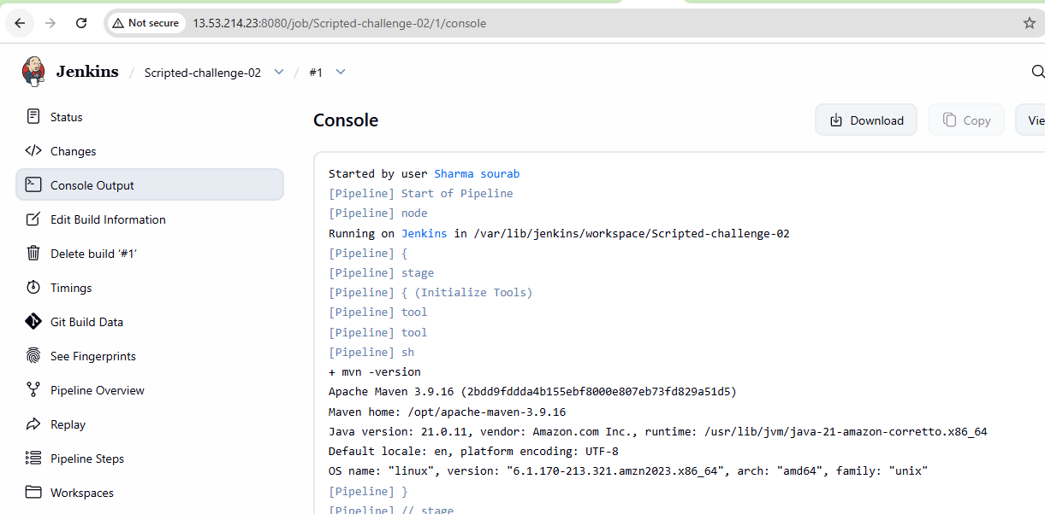
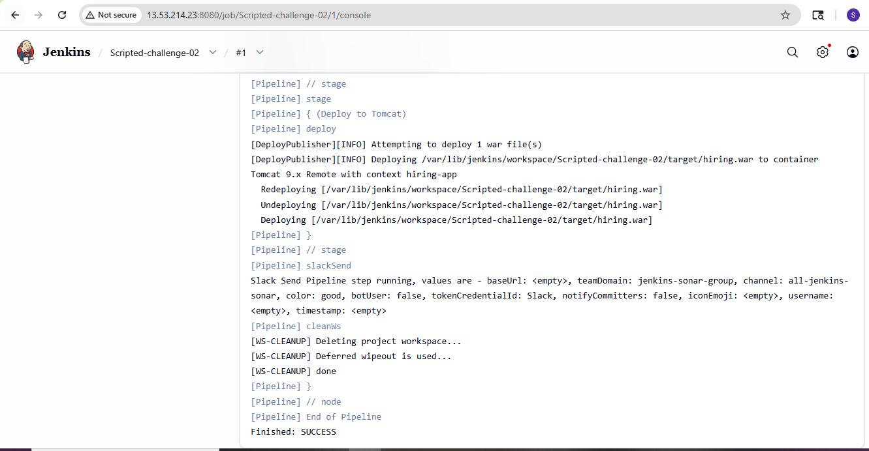
received the email notifications as well:
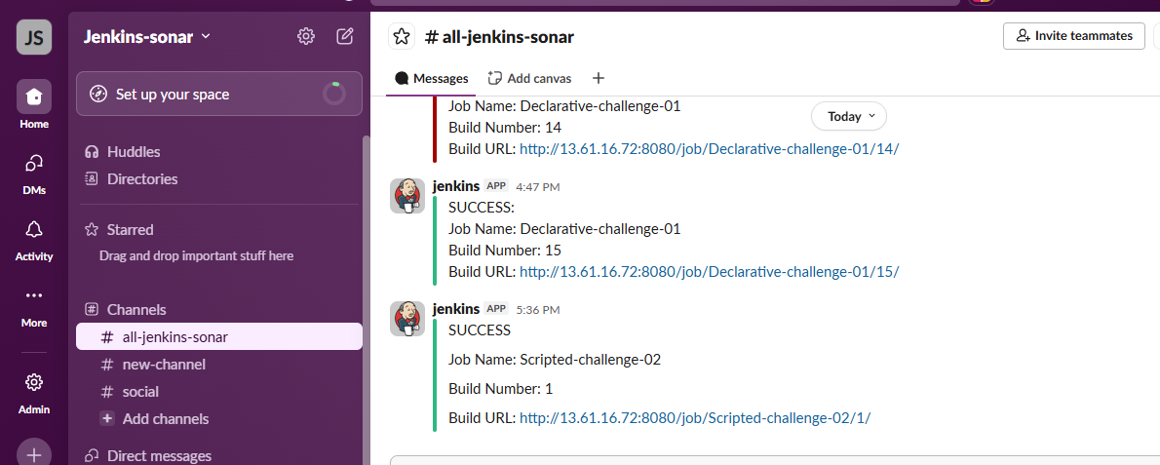
- Create one multi stage pipeline job:
Followed the same ChatGPT script here to get the script build done:
pipeline {

- agent any

- tools {
- maven 'Maven-home'
- }

- environment {

- // SonarQube
- SCANNER_HOME = tool('Sonar-scanner')

- // Nexus
- NEXUS_VERSION = "nexus3"
- NEXUS_PROTOCOL = "http"
- NEXUS_URL = "13.53.75.17:8081"
- NEXUS_REPOSITORY = "multistage-new"
- NEXUS_CREDENTIAL_ID = "Nexus-task-6000"

- // Artifact Details
- GROUP_ID = "in.javahome"
- ARTIFACT_ID = "hiring"
- VERSION = "0.1.${BUILD_NUMBER}-SNAPSHOT"

- // Tomcat
- TOMCAT_URL = "http://16.170.219.9:8080/"
- TOMCAT_CREDENTIAL_ID = "Tomcat-server"

- // Slack
- SLACK_CHANNEL = "all-jenkins-sonar"
- }

- stages {

- stage('Clean Workspace') {
- steps {
- cleanWs()
- }
- }

- stage('Clone Source Code') {
- steps {

- git branch: 'main',
- url: 'https://github.com/betawins/hiring-app.git'
- }
- }

- stage('Build Application') {
- steps {

- sh 'mvn clean compile'
- }
- }

- stage('Run Tests') {
- steps {

- sh 'mvn test'
- }
- }

- stage('SonarQube Scan') {
- steps {

- withSonarQubeEnv('Sonarqube') {

- sh """
- ${SCANNER_HOME}/bin/sonar-scanner \
- -Dsonar.projectKey=hiring-app \
- -Dsonar.projectName=hiring-app \
- -Dsonar.sources=.
- """
- }
- }
- }

- stage('Package WAR') {
- steps {

- sh 'mvn clean package -DskipTests'
- }
- }

- stage('Archive Artifact') {
- steps {

- archiveArtifacts artifacts: 'target/hiring.war'
- }
- }

- stage('Upload WAR to Nexus') {
- steps {

- nexusArtifactUploader(

- nexusVersion: NEXUS_VERSION,
- protocol: NEXUS_PROTOCOL,
- nexusUrl: NEXUS_URL,
- repository: NEXUS_REPOSITORY,
- credentialsId: NEXUS_CREDENTIAL_ID,

- groupId: GROUP_ID,
- version: VERSION,

- artifacts: [
- [
- artifactId: ARTIFACT_ID,
- classifier: '',
- file: 'target/hiring.war',
- type: 'war'
- ]
- ]
- )
- }
- }

- stage('Deploy to Tomcat') {
- steps {

- deploy adapters: [

- tomcat9(
- credentialsId: TOMCAT_CREDENTIAL_ID,
- path: '',
- url: TOMCAT_URL
- )

- ],

- contextPath: 'hiring-app',

- war: 'target/hiring.war'
- }
- }
- }

- post {

- success {

- slackSend(
- channel: "${SLACK_CHANNEL}",
- color: 'good',
- message: "SUCCESS: ${env.JOB_NAME} Build ${env.BUILD_NUMBER}"
- )
- }

- failure {

- slackSend(
- channel: "${SLACK_CHANNEL}",
- color: 'danger',
- message: "FAILED: ${env.JOB_NAME} Build ${env.BUILD_NUMBER}"
- )
- }

- always {
- cleanWs()
- }
- }
- }
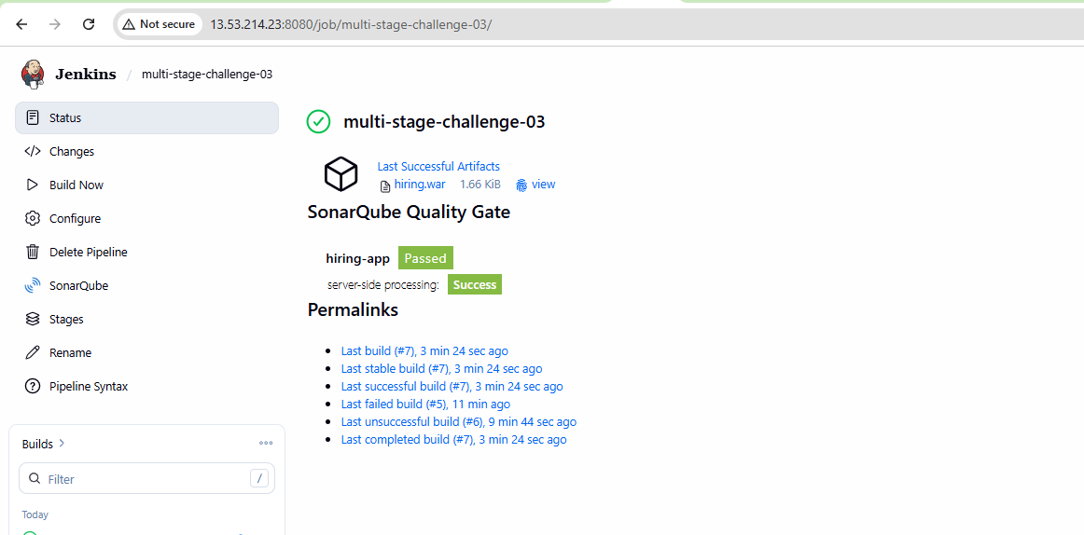
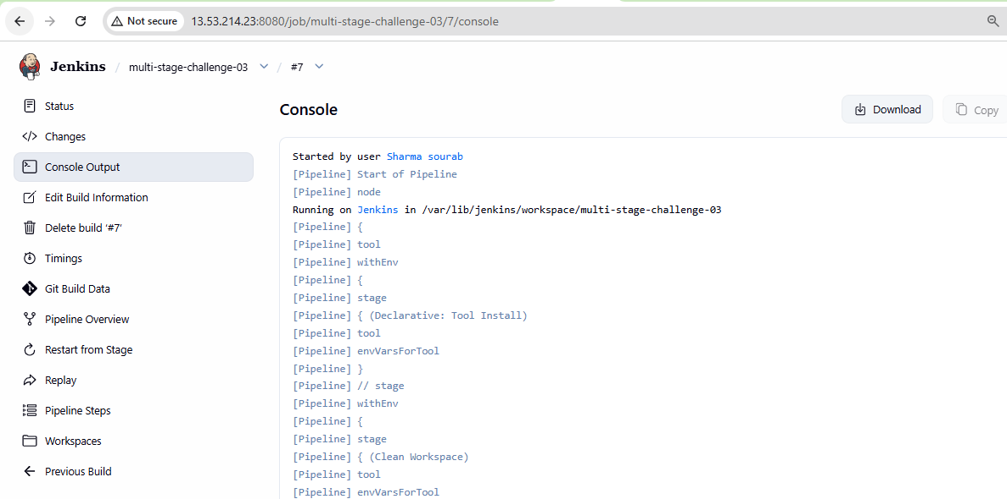
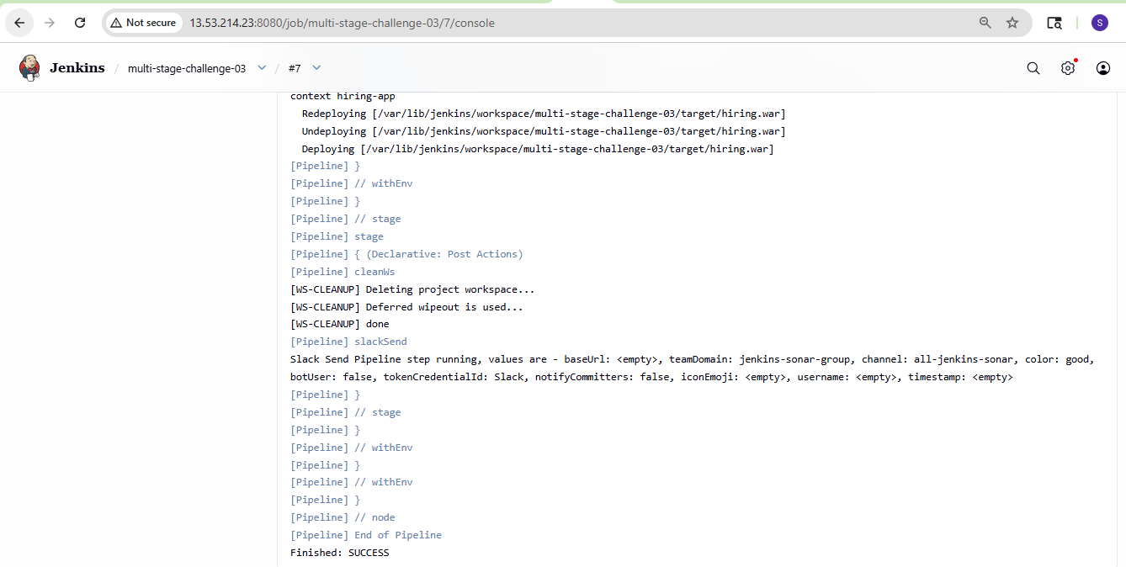
- Create one parallel stage pipeline job:
Followed the same ChatGPT script here to get the script build done:
pipeline {

- agent any

- tools {
- maven 'Maven-home'
- }

- environment {
- SCANNER_HOME = tool('Sonar-scanner')
- }

- stages {

- stage('Clean Workspace') {
- steps {
- cleanWs()
- }
- }

- stage('Clone Source Code') {
- steps {

- git branch: 'main',
- url: 'https://github.com/betawins/hiring-app.git'
- }
- }

- stage('Parallel Execution') {

- parallel {

- stage('Build') {
- steps {

- sh 'mvn clean compile'
- }
- }

- stage('Test') {
- steps {

- sh 'mvn test'
- }
- }

- stage('Sonar Scan') {
- steps {

- withSonarQubeEnv('Sonarqube') {

- sh """
- ${SCANNER_HOME}/bin/sonar-scanner \
- -Dsonar.projectKey=hiring-app \
- -Dsonar.projectName=hiring-app \
- -Dsonar.sources=.
- """
- }
- }
- }
- }
- }

- stage('Package WAR') {
- steps {

- sh 'mvn package -DskipTests'
- }
- }

- stage('Archive Artifact') {
- steps {

- archiveArtifacts artifacts: 'target/hiring.war'
- }
- }
- }

- post {

- success {
- echo "Pipeline completed successfully"
- }

- failure {
- echo "Pipeline failed"
- }

- always {
- cleanWs()
- }
- }
- }
